Quantitative Metabolomics Template
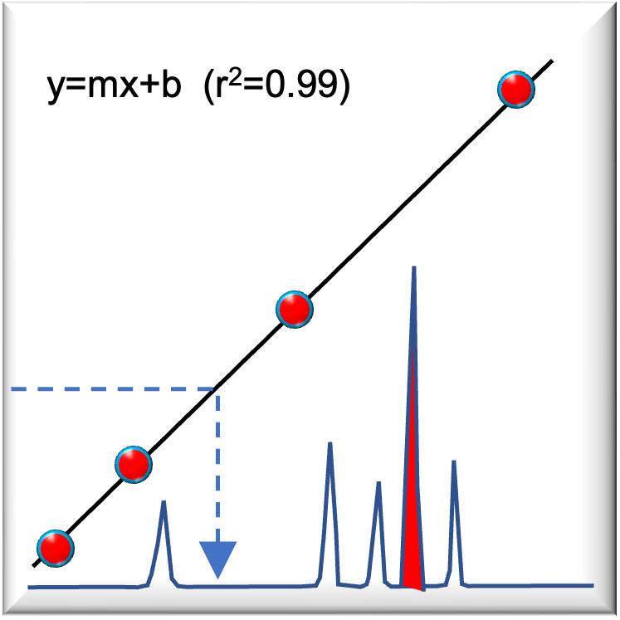

Date: mm/dd/yy

Analyte: analyte name

Matrix: serum, cell extract, water sample etc.

Instrument: Quattro Premier/TQ-Absolute

Method: method.olp

Overview:
Describe the overall aim and design of the study and the compounds to be analyzed for quantitation.
- What is the expected concentration range of the analyte(s) in your sample ?
- What internal standard(s) will be used ?
- How will samples be processed for LC-MS ?
- How types of replicates and quality control (QC) samples will be run ?

Conduct a comprehensive literature review of any relevant published LC-MSMS methods. Complete the methods table (Table 1: Method parameters) below with specific parameters from similar studies – Make note of the following parameters in the methods table below:
- Instrument systems (typem pf UPLC/MS system)
- Columns, solvent gradient conditions
- Analyte parameters: ion mode, parent/daughter ions, cone voltage (CV) and collision energy voltage (CE) etc.
- Quantitation limits: limit of detection (LOD) and limit of quantitation (LOQ) etc.

Comments:
- Summarize the comparison of published methods. Note weaknesses, strengths and compatibility to UCI MSF instrumentation.
- Review parameters with staff.

Method: Describe the specific choice to method to be used noting any changes. Complete the tables: Table 2. LC Gradient Conditions and Table 3. MS Quantitation. Also record reagent and materials information (product/lot #) in Table 4. Materials and Reagents.

e.g. The analytical method was based on method #3 but using a Waters C18 Fusion (2.1 x 50 mm, 1.7 µm) using (A) 10 mM Ammonium Formate + 0.1 % Formic Acid and (B) Acetonitrile + 0.1 % Formic Acid.

In brief, serum samples (100 µL) were mixed with 900 µL methanol, stored at -20°C for 30 minutes, then centrifuged to precipitate proteins. Supernatants were transferred to a new microfuge tube and i) diluted 1:10 for analysis, or ii) evaporated on a rotavap. Dried samples were resuspended in sample buffer for analysis.

Table 1: Method parameters

Parameter | Method A:  (1) | Method B: (2) | Method C: (3) | Method D: (4) | Method E: (5) | Method F: (6)
Instrument | SCIEX 4000 Q TRAP | Waters Quattro Ulltima | Micromass Quattro Premier XE | XCT plus ion trap | Sciex QTRAP 6500+ | Agilent 6460
LC System | Shimadzu | Dionex Ulitmate-3000 | Waters Acquity | HPLC 110 | MicroLC 200 | Agilent 1290 Infinity UHPLC
Column: | EZ FAAST 4 µ AAA-MS (250 x 2 mm) | Nucleoshell HILIC, EC 4/2, (2.7 µM) | Ultimate XB-C8 column, (3.0 μm, 2.1 mm × 50 mm) |  | ACE 3 AQ column (HiChrom), 0.5 x 150 mm | Phenomenex Kinetex C18 XB core–shell column (2.6 μm, 2.1 mm × 150 mm)
Solvent system | Buffer A: water + 1 mM FA  Buffer B: methanol + 1 mM FA | Buffer A: 25 mM NH₄.Formate pH 3.5. Buffer B: ACN | Buffer A: 40 nM NH₄.Formate + 0.1% FA  Buffer B: ACN | Buffer A: 20 mM NH₄. Formate + 0.1% FA  Buffer B: ACN | Buffer A: water + 0.1% FA  Buffer B: ACN | Buffer A: water + 0.3% HFBA + 0.5% FA  Buffer B: ACN + 0.3% HFBA + 0.5% FA
ES mode | POS | POS | POS | POS | POS | POS
Analyte Name | Glutamate | Glutamate | Glutamate | Glutamate | Glutamate | Glutamate
Analyte MF | C₅H₈NO₄⁻ | C₅H₈NO₄⁻ | C₅H₈NO₄⁻ | C₅H₈NO₄⁻ | C₅H₈NO₄⁻ | C₅H₈NO₄⁻
Analyte MW | 146.1213 | 146.1213 | 146.1213 | 146.1213 | 146.1213 | 146.1213
Derivative:
Parent (m/z) [A, IS] | 148.1 | 148.1, 153.1 | 381.1 | 148, 150.1 | 148.1 | 148.1, 154.1
Daughter (m/z) [A, IS] | 84 | 84, 134.9 | 17.0 | 130, 133.1 | 84 | 84.1, 89.1
Confirm (m/z) [A, IS] |  |  |  |  |  | 56.1
CV (V) |  | 35 | 20
CE (V) | 21 | 15 | 20 |  | 21 | 14
CXP (V) |  |  |  |  | 10
Cap (V) | 5500 |  | 3000 | 3500 |  | 3750
DP (V) |  |  |  |  | 21
EP (V) |  |  |  |  | 14.5
Gas Temp (ºC) | 550 | 4000 | 450 |  |  | 300
Gas flow (L/hr) | 1200 | 500 | 750 |  |  | 420
Collision gas (L/hr) |  |  | 0.0096
Dwell Time (s) |  | 0.02 | 0.1 |  |  | 0.02
RT (mins) |  | 13.9
LOD | 1 ng/mL |  |  | 20 nM | 5 fmol
LOQ | 5 ng/mL |  | 6.9 pmol/mL | 6 fmol
Int Std | Glutamate-d₃ | Glutamate-d₅ |  |  |  | ¹³C₅,¹⁵N-Glu

Table 2: LC Gradient Conditions

Solvent A: 10 mM Ammonium Formate + 0.1 % Formic Acid (pH 4.0)
Solvent B: Acetonitrile + 0.1 % Formic Acid
Column Temp (ºC): 50ºC

Time (mins) | Flow (mL/min) | % A | % B | Curve
Initial | 0.3 | 95 | 5
1.0 | 0.3 | 95 | 5 | 6
3.0 | 0.3 | 10 | 90 | 6
4.0 | 0.3 | 95 | 5 | 11
5.0 | 0.3 | 95 | 5 | 11

Table 4: MS Quantitation

Analyte | Parent ion | Daughter ion | Dwell (s) | CV (V) | CE (V)
L-Glutamate_1st | 148.1 | 130.1 | 0.3 | 21 | 21
L-Glutamate-d₃ | 151.1 | 133.1 | 0.3 | 21 | 21
L-Glutamate_2nd | n/a | n/a

Run time: 5 mins
Note: Wash column after experiment with 50/50 water/ACN to prolong column life.

Table 4: Reagents/Materials:

Reagent | Vendor | Product # | CAS # | Lot #
L-Glutamate | MP Bio | 194677 | 61060-04-3 | SR00870
L-Glutamate-d₃ | Cambridge Isotope Lab | DLM-335-1 | 96927-56-9 | PR-30709
MilliQ H₂O | In house |  |  | 18.2 MOhm
Acetonitrile | Fisher Optima LC-MS | A955-4 | 75-05-8 | 192474
Ammonium formate | Fisher Optima LC-MS | A115-50 | 540-69-2 | 168469
Formic acid | Fisher Optima LC-MS | A117-50 | 64-18-6 | 190283
Methanol | Fisher Optima LC-MS | A456-4 | 67-56-1 | 189401
Albumin (lyophilized powder) | Alfa Aesar | J66780 | 70024-90-7 | M29F079
Bovine serum albumin | Omega Scientific | FB-01 |  | 10057
Microfuge tubes
96-well sample plate | Waters 96-well, 350 µl | 186002643
96-well X-pierce sealing film | USA Scientific X-Pierce | 2997-0100

Sample Preparation:
Describe in detail your complete standard operating procedure (S.O.P.) for sample prep and calibration standards. Complex biological matrices, e.g. cell extracts, serum etc. will typically require sample processing to reduce/eliminate protein components and inorganic salts. Internal standards should be spiked into the samples prior to sample processing to normalize for extraction and recovery differences.

Example S.O.P.:

- Prepare 10 mL of a 10 mM stock solution of L-glutamic acid by dissolving 14.7 mg in 10 mL of MilliQ water d.H₂O. Aliquots (1 mL) were stored at -20ºC.
- An internal standard stock solution of 1 mM L-glutamic acid-d₃ was prepared by dissolving 1.47 mg into 10 mL dH₂O. L-GLU-d₃ IS was spiked into matrix, serum samples or calibration standard dilution buffer at a constant level of 10 µM concentration. Store aliquots at -20ºC.
- Prepare fresh standards of glutamic acid by 1:3 serial dilution in MilliQ water. Concentrations should start from 10 µM, 3.3 µM, 1.1 µM, 370 nM 0.5 nM and a 0 nM (IS only). IS is added at 100 nM in the dilution buffer.
- Serum samples (100 µL) were deproteinated by methanol precipitation. Mix 100 µl of serum with 400 µl of LCMS-grade methanol + IS (100 nM final).
- Samples were vortexed vigorously for 30 secs, stored at -20ºC for 30 minutes, then centrifuged at 12,000xg for 10 minutes at 4ºC.
- Following centrifugation, triplicate aliquots (@ 100 µl) of the supernatants were dried and then resuspended in 100 µl of 50% methanol and 0.2% formic acid for MS analysis.
- Matrix surrogates consisted of 100 µl of 10 mg/mL bovine serum albumin (BSA). Matrix samples were processed the same way as serum samples.
- Quality control (QC) samples were prepared by spiking matrix (BSA) with 1 nM (low) 100 nM (medium) or 1 µM (high) L-glutamic acid standards. Spiked samples were processed the same way.
- Precision, accuracy and Intra- and inter-day variation was assessed by inclusion of five injections of QC samples (l/m/h) run at the start and end of each experiment and once every 20 injections of samples to ensure validity of the calibration curve. Inter-day variation was assessed by running the sample set on day 1 and day 2.

Assay Performance

Robust assays for peer-reviewed publications should have their performance assessed in terms of specificity, linearity, precision and accuracy (intra and inter-day variation), limits of detection (LODs) and quantification (LOQs). The Food and Drug Administration (FDA) guideline on bioanalytical method validation [24 gives good summary of these criteria. The specificity of the method will be determined by comparing the blank chromatograms with those corresponding to supernatant samples. Blank samples were buffer without adding any component to the matrix.
The linearity of the calibration curve will be evaluated by analyzing compounds standard solutions at different concentrations. It is defined by the intercept of the calibration curve, slope and determination coefficient (R²). Good linearity are curves with R² ≥ 0.98. Calibration curves for each analyte will be obtained by linear regression analysis, and plotting the peak area ratio of analytes to the IS versus the theoretical concentration of analytes. The obtained results were used to calculate overall linearity as well as accuracy and precision at each concentration level.
To evaluate the precision and accuracy of the method, the intra-day and inter-day variations were assessed using three quality control (QC) points for each calibration curve that consists of three levels low, mid and high. The concentrations of QC points were 4, 80 and 800 ng/ml for Glu. Five replicates of each QC sample will be analyzed on the single day in order to evaluate intra-day variability and will be repeated a day later to determine inter-day variability. Precision will be expressed as relative standard deviation (%RSD) for replicate measurements and the value of accuracy was expressed as a relative error (%RE) by deviation between theoretical and calculated concentrations.
A series of decreasing concentrations of QC solution will be analyzed to determine the LOD and LOQ. LOD is the minimum amount of analytes detectable in the sample, while the LOQ is the minimum amount that can be quantified by the method. These parameters will be calculated from the signal-to-noise ratio (LODs signal-to-noise = 3, LOQ signal-to-noise = 10).

Table 5: Example Sample List
Sample # | Sample Name | Type | Conc (nM) | Observed | % recovery | % CV
1 | Blank 1 | Blank
2 | Blank 2 | Blank
3 | M-IS | Analyte | 0
4 | Matrix ctrl (A) | QC | 0
5 | Matrix + low spike | QC | 10
6 | Matrix + med spike | QC | 100
7 | Matrix + high spike | QC | 1000
8 | Blank 3 | Blank
9 | Blank 4 | Blank
10 | Sample 1a | Analyte
11 | Sample 2a | Analyte
12 | Sample 3a | Analyte
13 | Sample 1b | Analyte
14 | Sample 2b | Analyte
15 | Sample 3b | Analyte
16 | Blank 5 | Blank
17 | Blank 6 | Blank
18 | 0 µM Std | Standard | 0
19 | 1.5 nM Std | Standard | 1.5
20 | 4.5 nM Std | Standard | 4.5
21 | 12.7 nM Std | Standard | 13.7
35 | 4.1 nM Std | Standard | 41
22 | 123 nM Std | Standard | 123
23 | 370 nM Std | Standard | 370
24 | 1111 nM Std | Standard | 1111
25 | 3333 nM Std | Standard | 3333
26 | 10000 nM Std | Standard | 10000
27 | Dirty Wash | Blank
28 | Blank 7 | Blank
29 | Blank 8 | Blank
30 | M-IS | Analyte | 0
31 | Matrix ctrl (B) | QC | 0
32 | Matrix + low spike | QC | 10
33 | Matrix + med spike | QC | 100
34 | Matrix + high spike | QC | 1000
35 | Blank 9 | Blank
36 | Blank 10 | Blank

References
1. Cebi, N., Dogan, C. E., Olgun, E. O., and Sagdic, O. (2018) A survey of free glutamic acid in foods using a robust LC-MS/MS method. Food Chem 248, 8-13
2. Defaix, C., Solgadi, A., Pham, T. H., Gardier, A. M., Chaminade, P., and Tritschler, L. (2018) Rapid analysis of glutamate, glutamine and GABA in mice frontal cortex microdialysis samples using HPLC coupled to electrospray tandem mass spectrometry. J Pharm Biomed Anal 152, 31-38
3. Zhang, L. H., Cai, H. L., Jiang, P., Li, H. D., Cao, L. J., Dang, R. L., Zhu, W. Y., and Deng, Y. (2015) Simultaneous determination of multiple neurotransmitters and their metabolites in rat brain homogenates and microdialysates by LC-MS/MS. Analytical Methods 7, 3929-3938
4. Zhang, X., Rauch, A., Lee, H., Xiao, H., Rainer, G., and Logothetis, N. K. (2007) Capillary hydrophilic interaction chromatography/mass spectrometry for simultaneous determination of multiple neurotransmitters in primate cerebral cortex. Rapid Commun Mass Spectrom 21, 3621-3628
5. Lane, C. S. (2015) Rapid LC-MS/MS Analysis of Free Amino Acids in Extracellular Matrix.
6. Purwaha, P., Silva, L. P., Hawke, D. H., Weinstein, J. N., and Lorenzi, P. L. (2014) An artifact in LC-MS/MS measurement of glutamine and glutamic acid: in-source cyclization to pyroglutamic acid. Anal Chem 86, 5633-5637

